
A12
Sreenidhi Institute of Science and Technology
(An Autonomous Institution)
Code No: 3C513
B. TECH. III-Year I-Semester Examinations, December 2015 (Supplementary)

LINEAR AND DIGITAL IC APPLICATIONS
(Common to EEE, ECE & ECM)

Time: 3 Hours Max. Marks: 70

Note: No additional answer sheets will be provided.

Part - A
Max.Marks:20

Answer all QUESTIONS. EACH QUESTION CARRIES 2 MARKS.
1. The common mode input to a certain differential amplifier having differential gain of
125 is 4sin 200πt Volts. Determine the common mode output, if CMRR is 60dB?
2. Draw the frequency response curve of a differentiator. How it is modified when a
small resistor is connected in series with capacitor?
3. Calculate the value of resistance required in a second order low pass Butterworth filter having cut-off frequency of 15KHz, with a capacitor of 0.02µf ?
4. Why is the R-2R ladder network DAC is better than weighted resistor DAC?
5. Draw the circuit diagram of CMOS inverter and explain its operation using truth table.
6. Draw the logic diagram and truth table of 2 to 4 decoder.
7. Define slew rate? What causes the slew rate? Write the expression for maximum frequency of slew rate?
8. Illustrate the advantages of active filters over passive filters.
9. List out the important features of Emitter Coupled Logic (ECL).
10. Draw the truth table and logic diagram of Master Slave JK Flip Flop.

Part – B
Max.Marks:50

ANSWER ANY FIVE QUESTIONS. EACH QUESTION CARRIES 10 MARKS.
1. a) List the non-ideal DC characteristics of an OP-AMP. Explain any two parameters in detail?
b) An op-amp with a slew rate = 0.5V/μs is used as an inverting amplifier to obtain a gain of 100. The voltage gain Vs frequency characteristic of the amplifier is flat up to 10 KHz. Determine
  - The maximum peak-to-peak input signal that can be applied without any distortion to the output .
  - The maximum frequency of the input signal to obtain a sine wave output of 2V peak.

2. a) Draw the circuit diagram of instrumentation amplifier used to measure the temperature and explain its working in detail by deriving output expression?

b) Find the output voltage for the circuit shown below:
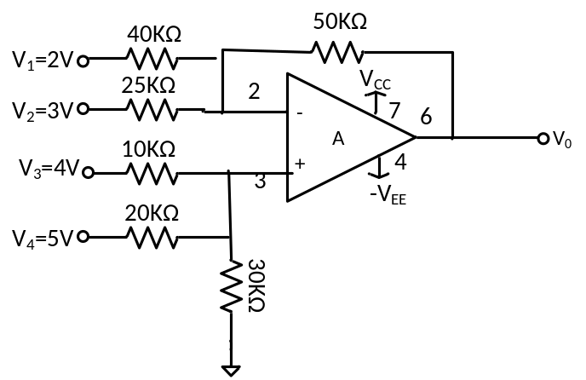

3. a) Derive the transfer function, gain, and phase angle for first and second order low pass active filters.
b) Design a PLL circuit using 565IC to get free running frequency of 4.5KHz with lock range of 2KHz and capture range of 100Hz. Assume supply voltages of 10V. Also draw the circuit diagram.
4. a) Draw the block diagram of 4-bit successive approximation A/D converter and explain its operation with the help of output waveform.
b) Design a RC phase shift oscillator for 300Hz frequency using IC741 and 15V power supply?

5. a) Briefly describe the characteristics of TTL and CMOS logic families.
b) Describe tri-state logic (TSL) using TTL logic family. Draw and explain the circuit of a TSL NAND gate.

6. a) Differentiate between a multiplexer and a demultiplexer. Using two 74151s, design a 16-line multiplexer controlled by four data select control inputs.
b) Design a 6-bit adder using two 74283 ICs.

7. a) Draw the block diagram of IC 566 VCO and explain its operation.
b) An astable multivibrator has R_{A}=2.2KΩ, R_{B}=6.8KΩ and C=0.01µf. Calculate
i) t_{HIGH} ii) t_{LOW} iii) free running frequency iv) Duty cycle
8. a) Explain the working of a weighted resistor D/A converter and state the limitations of it.
b) Explain in detail the working of a positive edge triggered D-type flip-flop.

-- 00 -- 00 –

